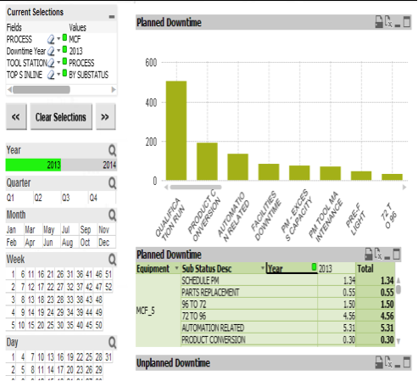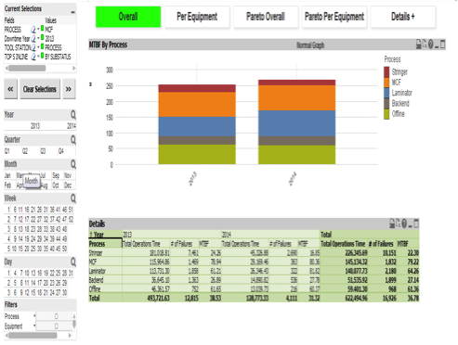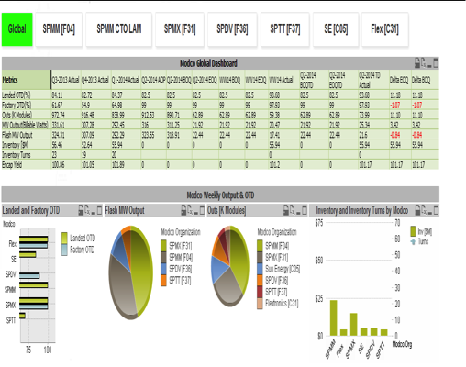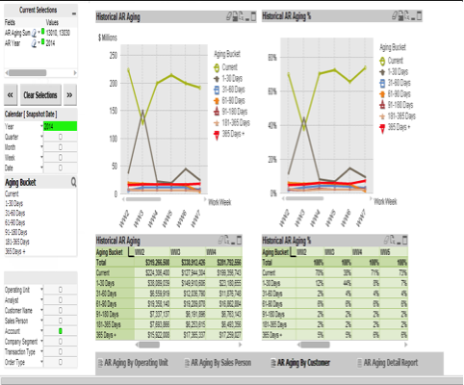

White Paper, April 2014

**Achieve More from your ERP using QlikView Business Intelligence**

With more and more organizations realizing the need for Business Intelligence applications to help the effective decision making for their businesses, choosing the right BI application has become a significant challenge. Analytics and visualization of business data empowers the executive and operational teams at various levels to make the right decisions. QlikView has moved significantly along both these dimensions and is gaining a lot of attention for the right reasons among the organizations as a potential BI tool to enable their organizations to move towards efficient and effective decision making.

Triniti realizes the potential of QlikView and has been providing the development services in this segment. QlikView’s inherent flexibility to build complex data models through its proprietary scripting language makes it easier to address the most complex dashboard / reporting needs. QlikView is an in-memory application, ensuring faster access to data at the user interface layer.

Triniti has mastered the development nuances of QlikView and has an expert team of consultants who can help you achieve more out of your ERP application. Triniti consultants can help you throughout the lifecycle of BI application development and maintenance.

Introduction

Problem of Too Many Options

The market is currently flooded with business intelligence applications. Choosing the right fitment for your organization is a daunting task. No single BI product can address all necessary requirements, so it is important to prioritize requirements diligently and try to look for a product that best aligns with your needs. As per Gartner’s magic quadrant on BI tools available in the market, QlikView is amongst the top leaders in this segment that can address most business requirements. Triniti also recommends QlikView as the preferable option to meet your BI needs.

**BI Developers vs consultants:** After you have made the right selection, it is imperative that you select the right implementer to help you make effective use of your BI tool. With the emergence of so many BI tools, finding skilled BI developers is not too challenging. Finding someone who fully understands your ERP and underlying business processes is the real challenge. Triniti has been able to effectively fill this gap due to its long association with ERP business. Since its inception, Triniti has been working in the area of Oracle E-Business Suite (Oracle EBS). This has ensured that all BI developers from Triniti’s pool of resources have the right mix of development skills and ERP understanding.

Triniti Advantage

Triniti has been able to create a unique proposition for QlikView development services due to its competent pool of resources, who have good exposure on the ERP side, especially with Oracle EBS. That knowledge can easily be utilized while designing and developing any new BI dashboards / reports using QlikView.

**End-to-end services for dashboard developments:** Triniti consultants can support end-to-end implementation of QlikView dashboards / reports right from requirement gathering to designing, development, deployment and maintenance. Triniti’s QlikView consultants also are enriched with implementation experience which comes in handy while deploying QlikView applications as well.

**End-to-end business understanding:** Triniti has built QlikView applications spanning across various business functions, like sourcing / procurement, manufacturing execution, sales, planning & finance. We understand important business metrics, which enable you to make efficient decisions backed by data. Below are some of the examples of dashboards which Triniti’s QlikView consultants have developed as part of our existing client base in this space.

**Manufacturing Application using Qlikview**

|  |  |
| --- | --- |
|  | *Manufacturing dashboard to depict mean time between failures. The dashboard provides equipment wise failure details, pareto analysis etc* |

|  |  |
| --- | --- |
| *Manufacturing dashboard to depict planned downtime by equipment.* |  |

|  |  |
| --- | --- |
|  |  |

**Accounts Receivables Dashboard using QlikView**

|  |  |
| --- | --- |
|  | *AR dashboard here depcits the historical receivables aging and trending by periods.The same dasboard also shows AR aging details as on date but historical trending is a critical metric for the businesses* |
|  |  |

|  |  |
| --- | --- |
| *Dashboard here depicts various critical metrics on a single screen e.g. Ontime Delivery, Outputs, Inventory and inventory turn details* |  |
|  |  |

**Another sample dashboard for Ontime Delivery measurement**

|  |  |
| --- | --- |
|  | *Dashboard here depicts various critical metrics on a single screen e.g. Ontime Delivery, Outputs, Inventory and inventory turn details* |

**Faster turn-around with better quality:** Triniti team can help you achieve faster turn-around time on new developments and enhancements, while assuring top quality. Triniti follows a unique implementation methodology well suited for BI applications deployment. There are two critical metrics that Triniti has adopted and monitors during the course of any development cycle. The first is the number of clicks users make to get to the right information on BI dashboards and reports. The second is the number of re-works on each report that is developed and delivered. The first metric ensures that the user experience is less cumbersome, while the second ensures that the delivery of output is of top quality.

**Achieve more from your ERP by using Triniti’s QlikView expertise:** Our consultants’ broad experience with ERP applications, coupled with its unique methodology for BI application deployment, can help you realize your return on investment with QlikView much faster.

Triniti’s QlikView team is comprised of consultants with significant experience in the Oracle ERP space, with SQL & PL/SQL knowledge and good handle on QlikView scripting and UI skills. Triniti’s QlikView consultants are competent enough to play varied roles for any QlikView implementation right from gathering business requirements, understanding them, mapping them, modeling them in QlikView to converting them into attractive and user friendly dashboards & reports.

**Derive, Visualize, Analyze and Decide effectively:** Triniti’s QlikView development services would provide you end-to-end coverage right from extraction of the right data from your ERP application to the visualization layer, empowered with right analytical capabilities, to help you in effective decision making process.

For further details on Triniti’s QlikView practice, please reach out to [products@triniti.com](mailto:products@triniti.com)